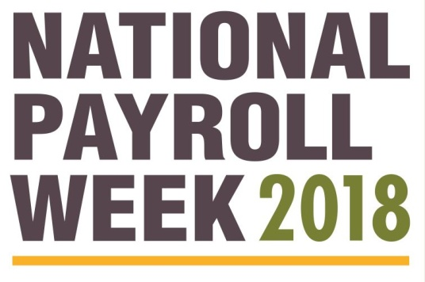

Q: Why is there a National Payroll Week?

A. Everyone loves payday. Payroll is an important and basic component of every employee’s
life. Many employees often take the processing of this crucial transaction for granted. Payroll
professionals must be able to follow constantly-changing federal, state and local regulations.
There are numerous and complex tax regulations that vary from state to state. Despite these
challenges, payroll professionals calculate each paycheck accurately and on time, every time.
For this, we salute all payroll professional during National Payroll Week.

Q. Why should we celebrate payroll professionals?

A. Payroll taxes are the lifeblood of America. Through the payroll withholding system, payroll
professionals report, collect, and deposit approximately 70 percent of the annual revenue of
the U.S. Treasury. The taxes collected by payroll professionals support the American way of
life by funding local and national programs that benefit all Americans. From highways, to
federal benefits programs like social security, to educating our children, payroll keeps
America working.

Q. Why is National Payroll Week held annually during the week of Labor Day?

A. The week of Labor Day celebrates universal ideals important to everyone who earns a
paycheck. These ideals include the significance of “an honest day’s work for an honest day’s
pay,” the economic, cultural, and social achievements of employees, and the partnership
between employees and their employers.

Q. What can American employees learn from National Payroll Week?

A. National Payroll Week helps employees get more money from their paycheck. NPW educates
workers on sound ways to manage their paycheck and achieve financial stability. NPW
focuses attention on flexible spending accounts, direct deposit, proper withholding amounts,
the importance of updating social security information, and other payroll topics critical to
sound personal financial management.

